| **Test Name** | | Edit Error Submission Form | | | |
| --- | --- | --- | --- | --- | --- |
| **Use Case Tested:** | | Use Case – Edit Error Submission Form | | | |
| **Test Description:** | | User needs to change what fields are shown in the Error Form  User navigates to Manage Error Form page  User is presented with selectors to control which fields are shown  User selects the fields they want shown or unselects others  User submits selections | | | |
| **Pre-conditions** | | None | | | |
| **Post-conditions** | | The Error form reflects the changes and will add null values to the database where fields are hidden. | | | |
| **Notes:** | |  | | | |
| **Result (Pass/Fail/Warning/Incomplete)** | |  | | | |
|  | **TEST STEP** | | **EXPECTED TEST RESULTS** | P | F |
|  | User selects “Search > Manage Error Form” from the menu bar or selects Manage Error Form button on Admin Home page | | The Edit Error Form page appears – using Button  The Edit Error Form page appears – using Menu Bar | X3  X3 |  |
|  | User selects the fields to be displayed | | Input does not show error | X3 |  |
|  | User selects Submit button | | Message appears that the form was updated | X3 |  |
|  | User views the error form | | Error form reflects the changes made | X3 |  |
|  | User fills out the available fields | | The error form submits without error.  The error in the database reflects the selected fields. | X3  X3 |  |

|  |  |  |  |  |  |
| --- | --- | --- | --- | --- | --- |
| **Test Data Table** | | | | | |
|  | **1** | **2** | **3** | **4** | **5** |
| Test – 1 | All toggle able fields enabled |  |  |  |  |
| Test – 2 | All toggleable fields disabled |  |  |  |  |
| Test – | Random selection (patient, location, severity) of fields enabled. |  |  |  |  |
|  |  |  |  |  |  |

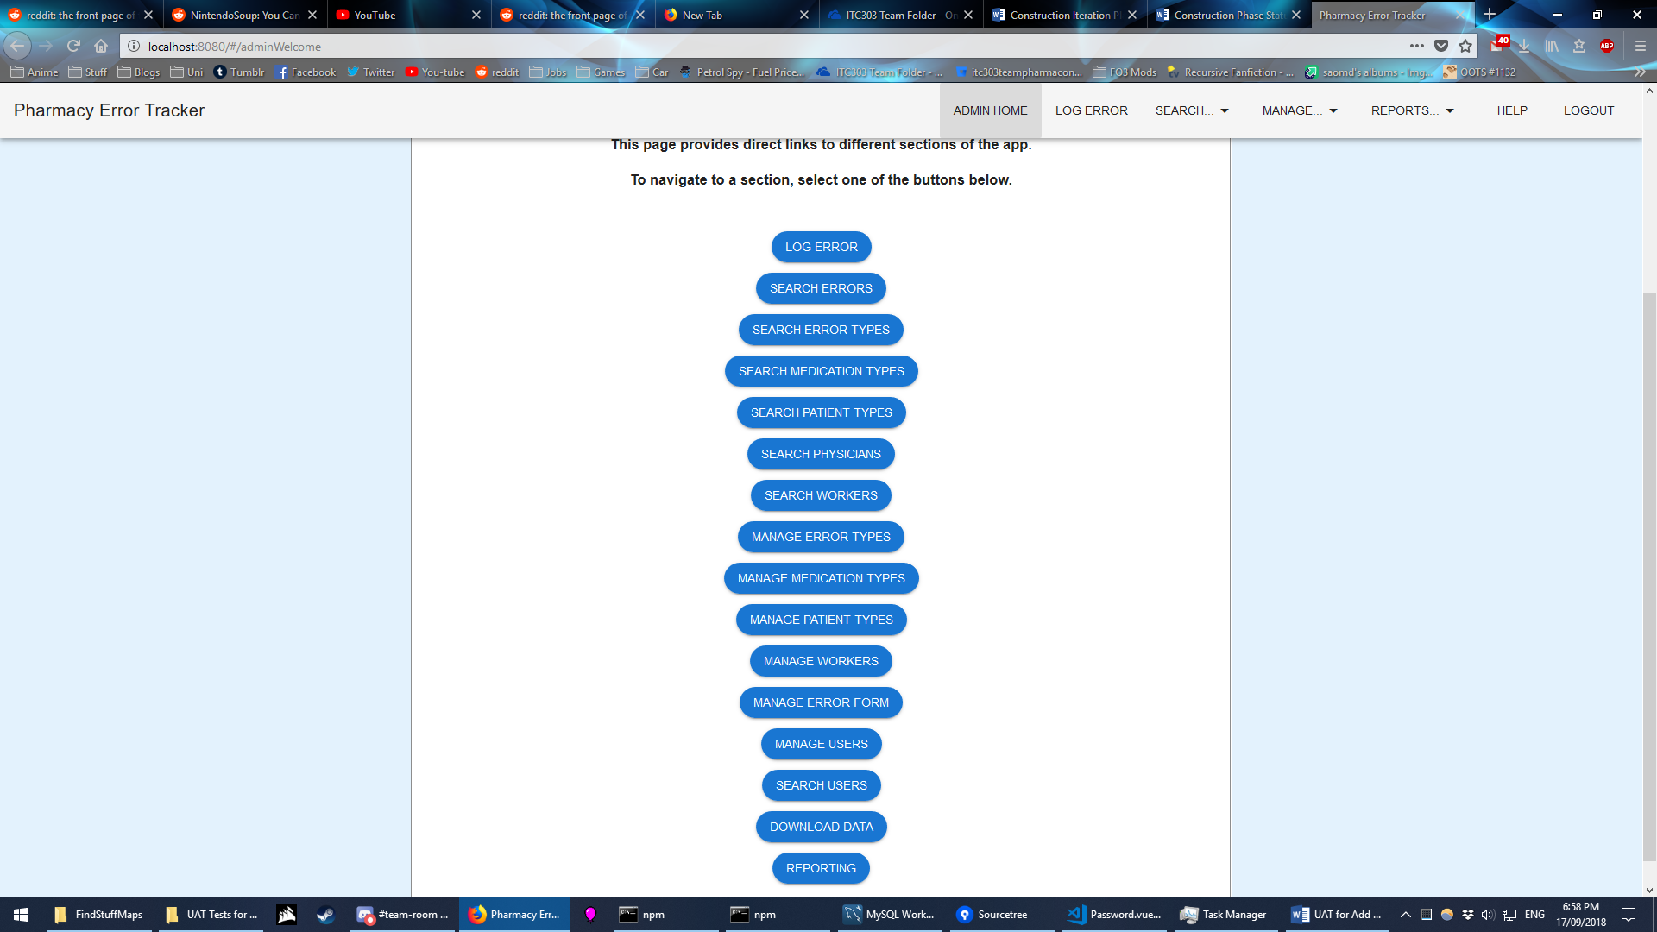

Figure 1: Select Manage Error Form via Button

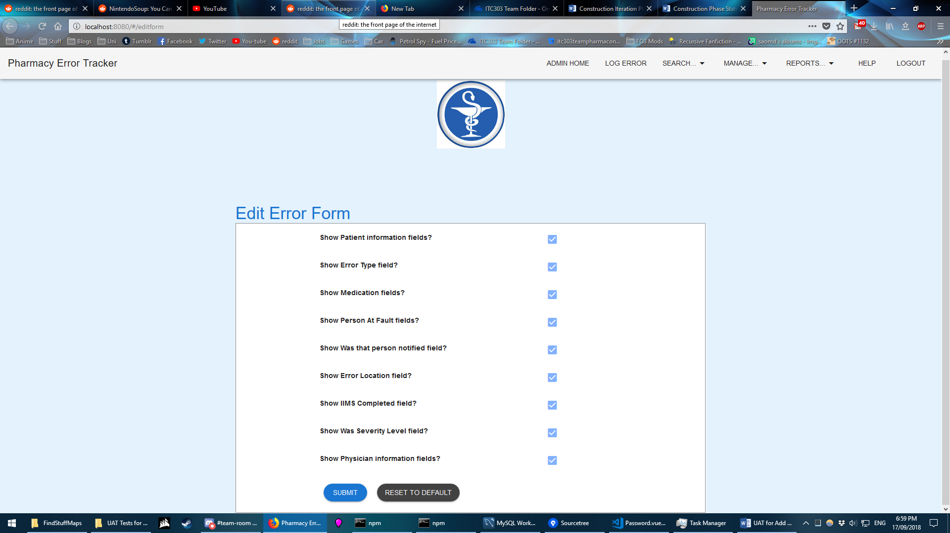

Figure 2: Manage Error Form is loaded



Figure 3: Select Manage Error Form via Menu Bar

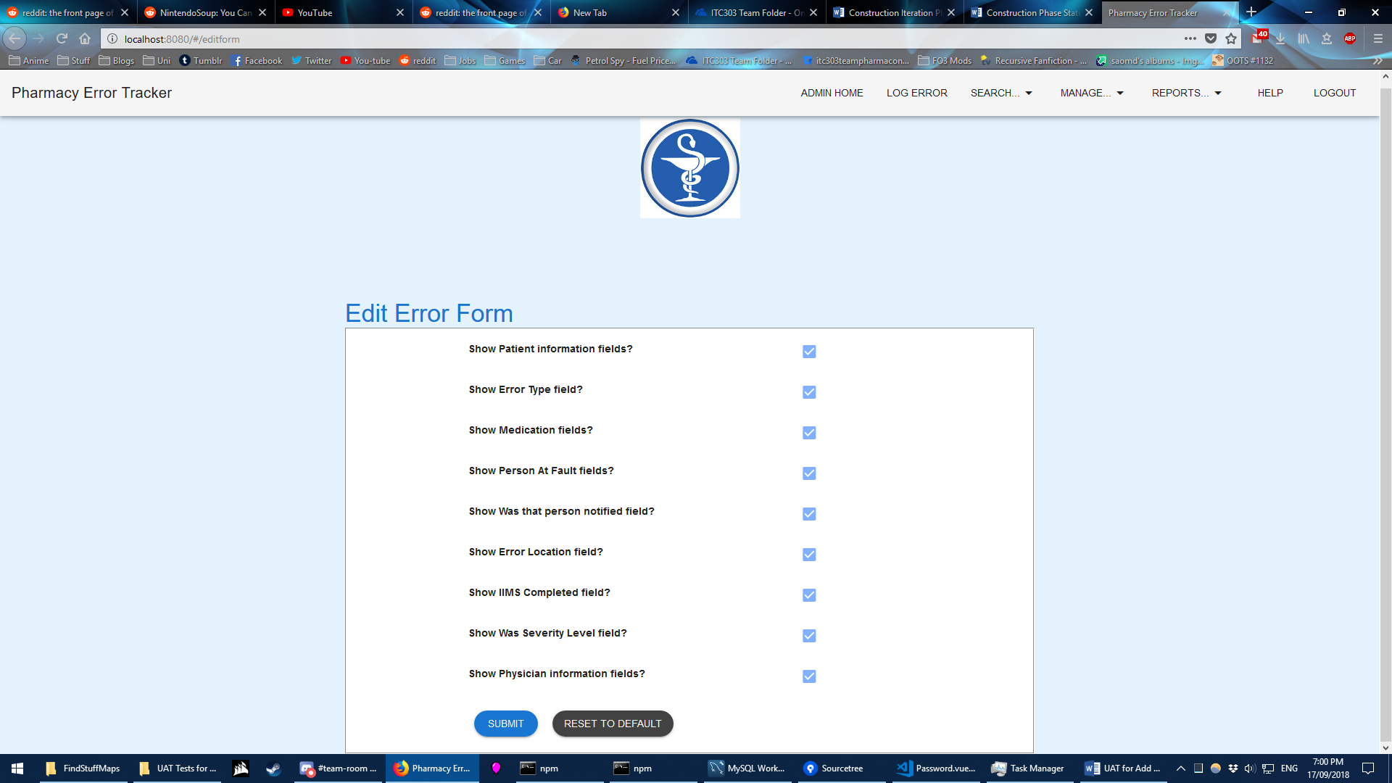

Figure 4: Manage Error Form is loaded

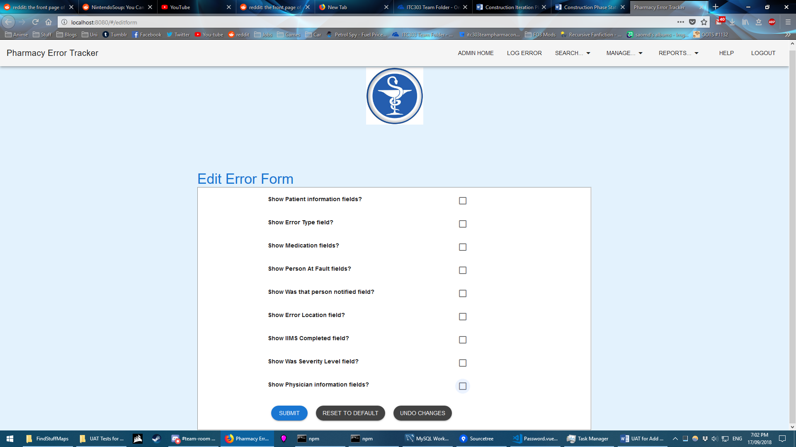

Figure 5: Details entered (test 2 for demonstration)

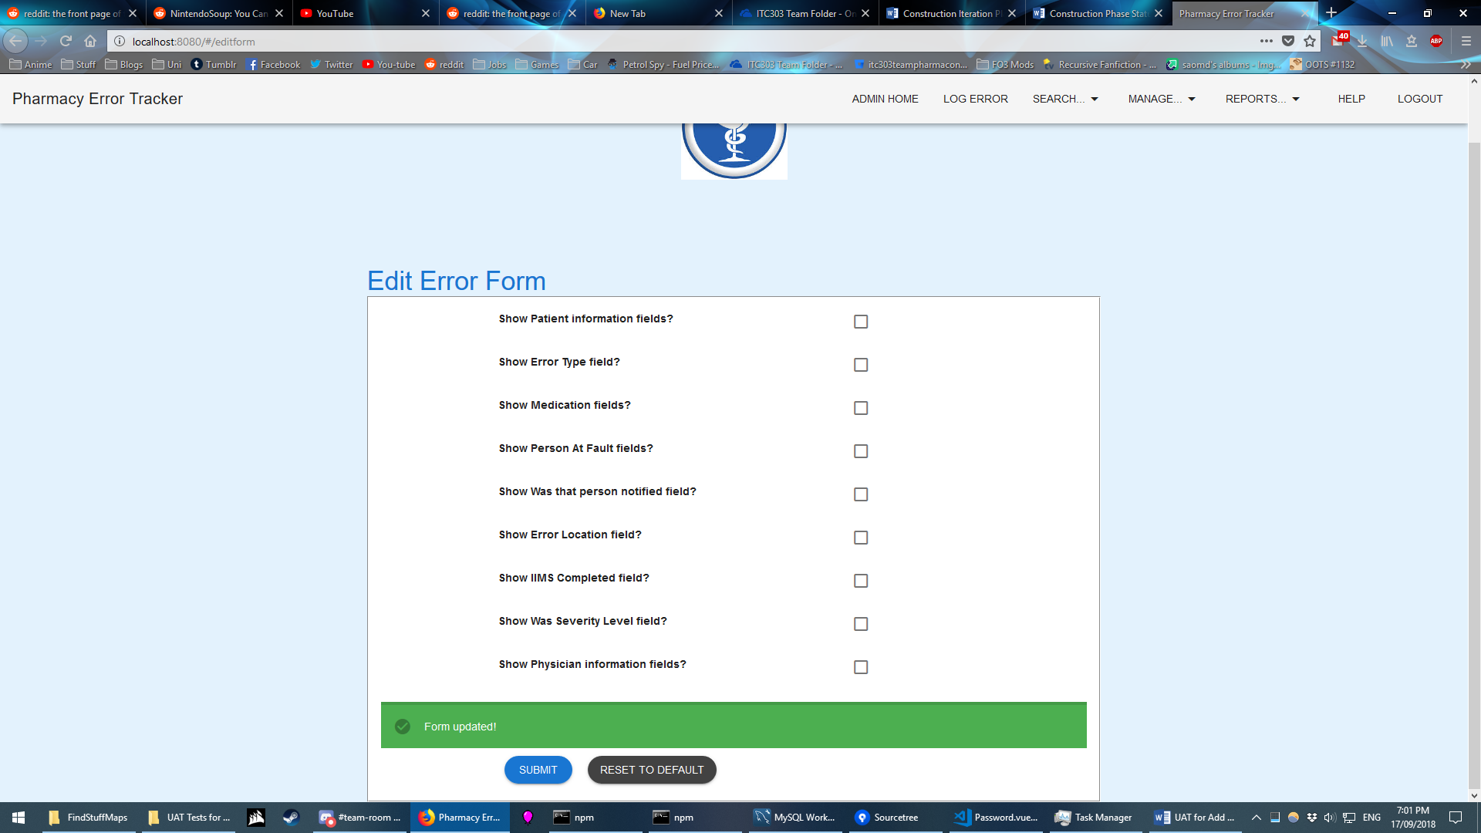

Figure 6: Submit button selected. Success message returned

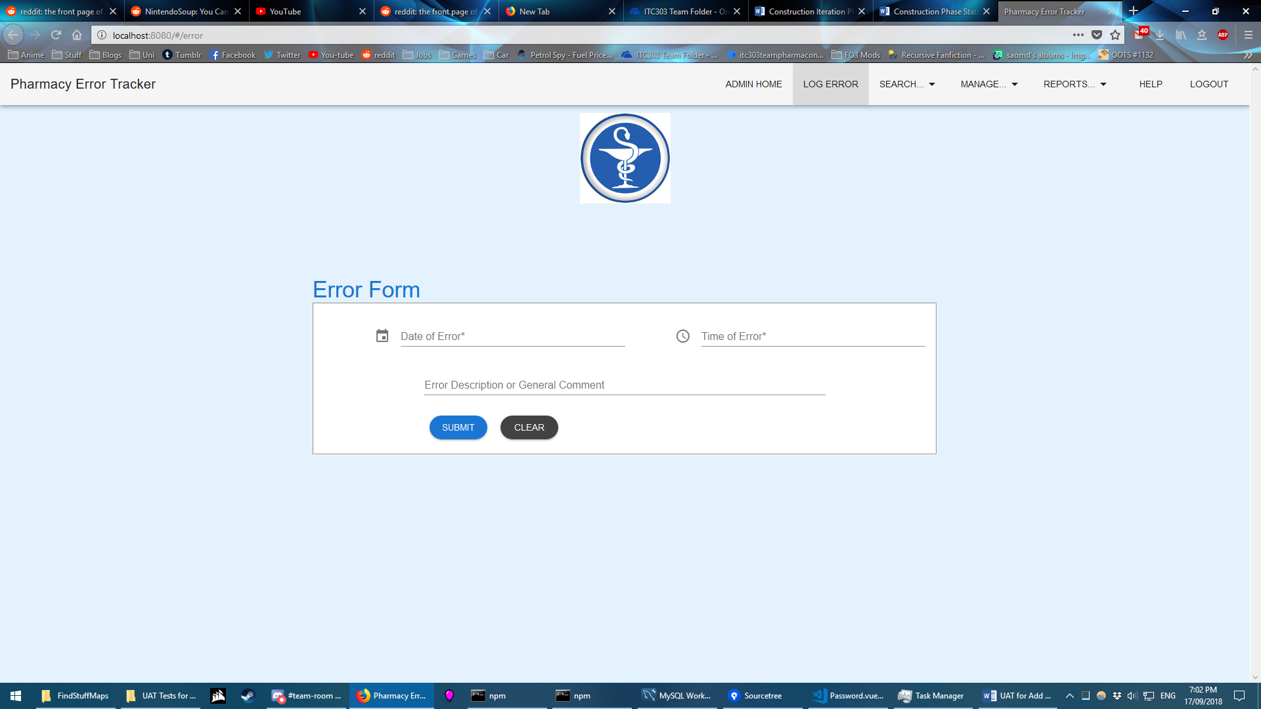

Figure 7: Error form shows the selected fields are hidden.

EXPECTED ERRORS:

None

EXPECTED BEHAVIOUR

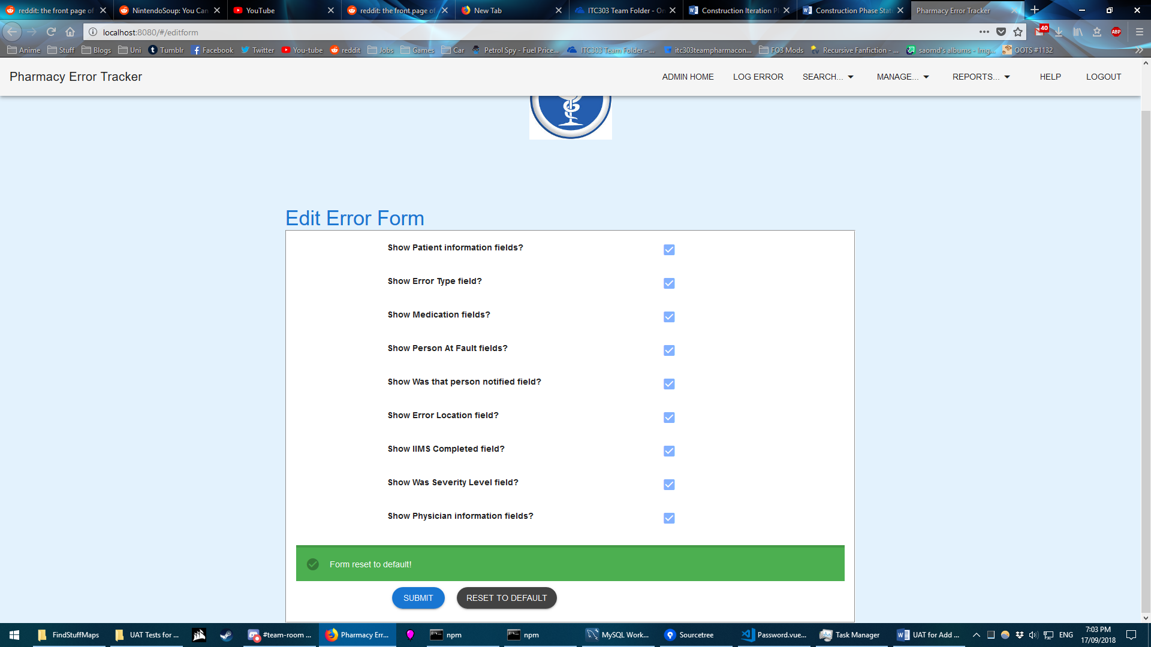

Figure 8: Selecting Reset to Default enables all fields – Expected

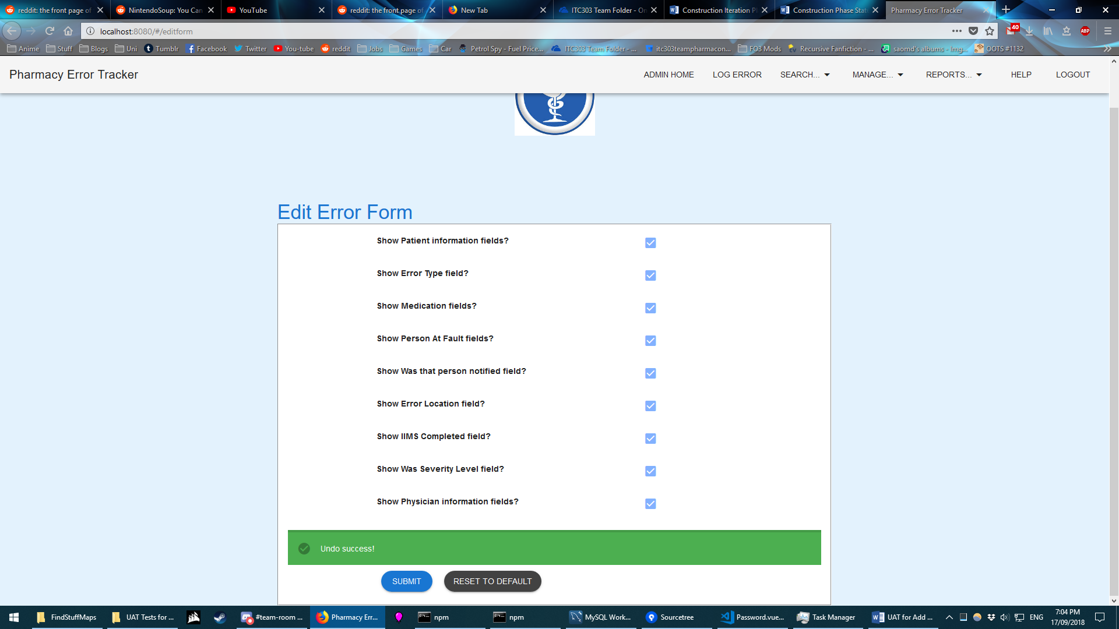

Figure 9: Selecting Undo Changes reverts the form to the previously submitted state – Expected  
  
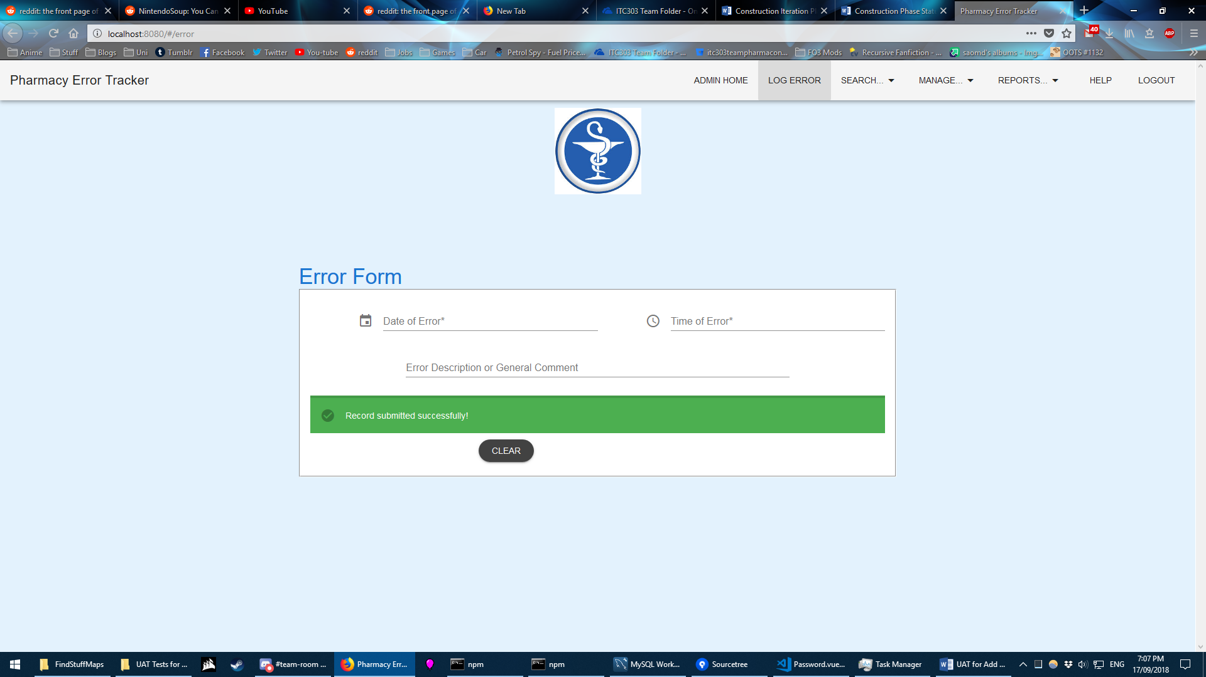 Figure 10: Submitting an error still works without error even with just the minimum fields – Expected

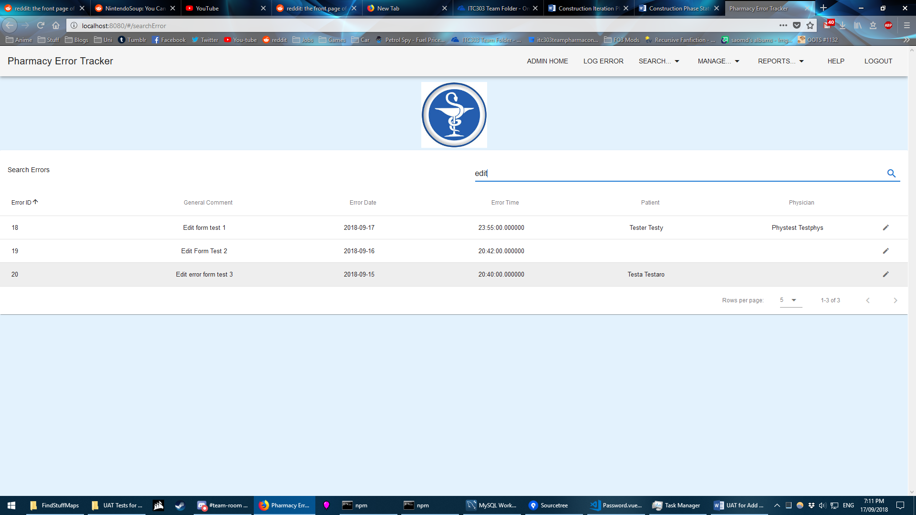

Figure 11: Submitting errors exist in the database and can be searched – Expected

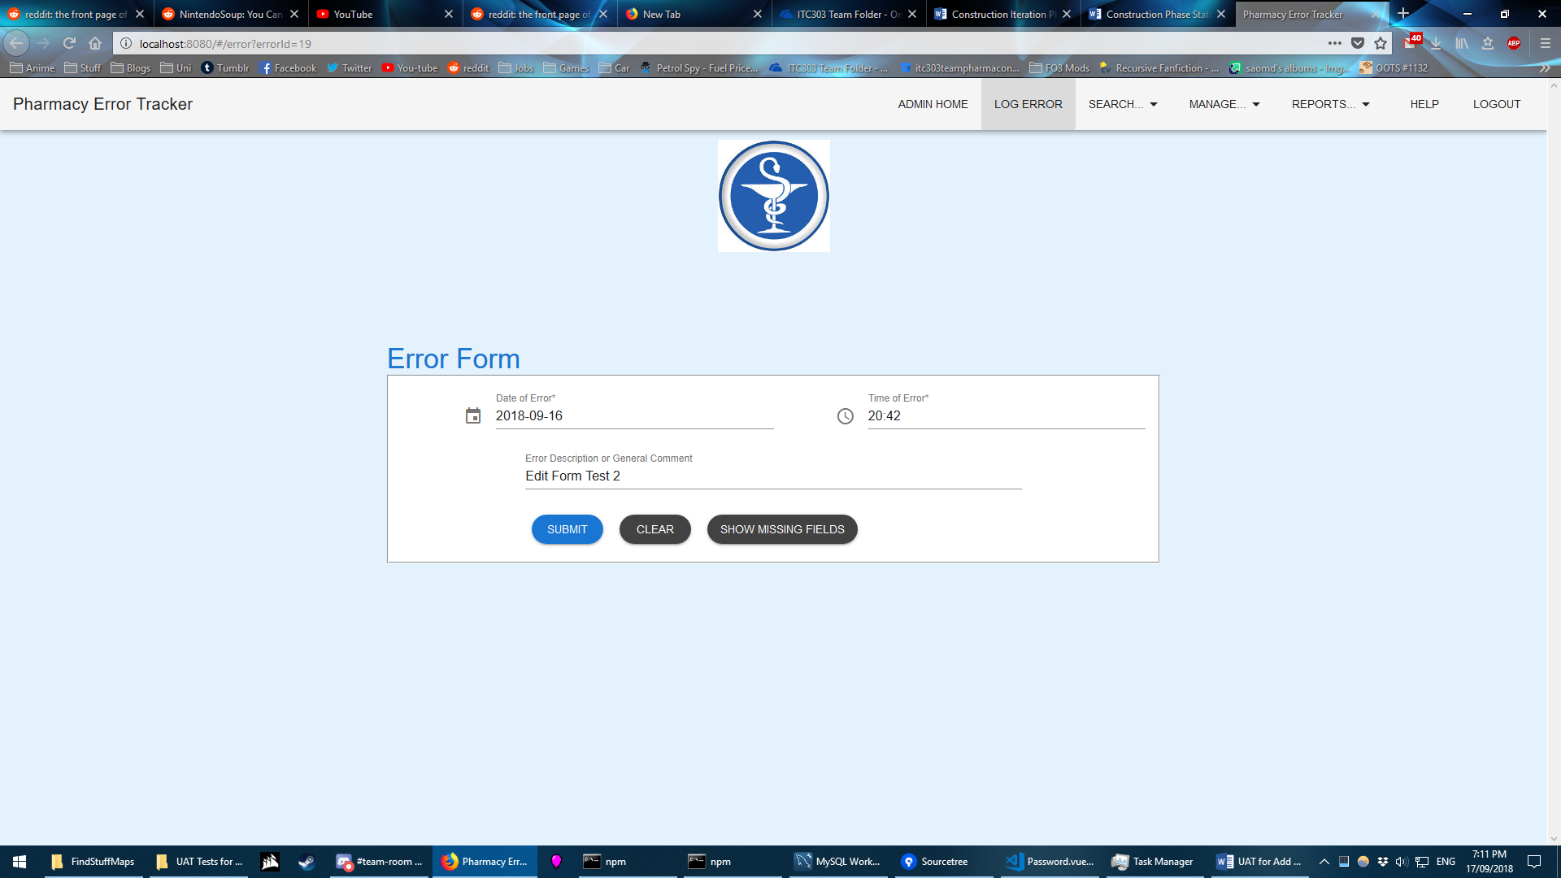

Figure 11: Submitted errors can be edited – fields hidden at the time of error creation will still be hidden, but can be shown with the Show Missing Fields button– Expected